Game Rental System - PHP

# **Login Page:**

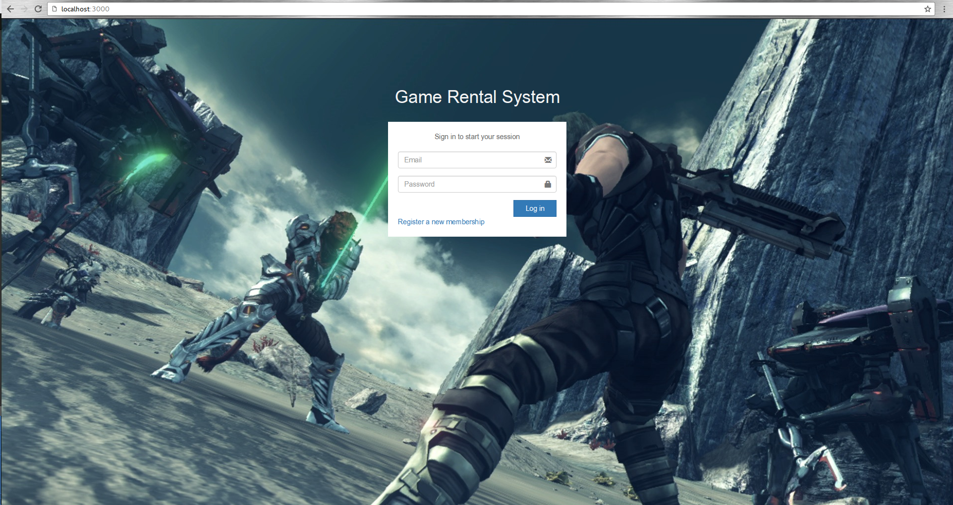

In this page, when user enters email and password and click on ‘Login’, both fields data are get from the fields and an AJAX call is send to database through Javascript that checks the validation of credentials, if that call return true, it will be redirect to motel page and in the case of false return, the message is shown through Jquery function.

# **Signup/Register Page:**

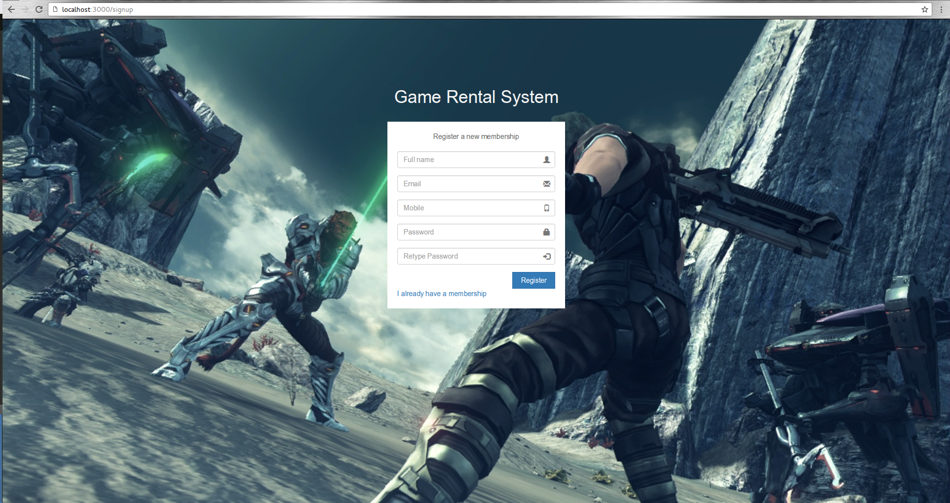

While register the user, we take full name (that can be any), email (email is validated here with Jquery validator), mobile number and passwords and when clicking on “Register”, this all data is taken to database via Javascript and response will tell that account is created and all data is stored in the database.

# **List of Games Page:**

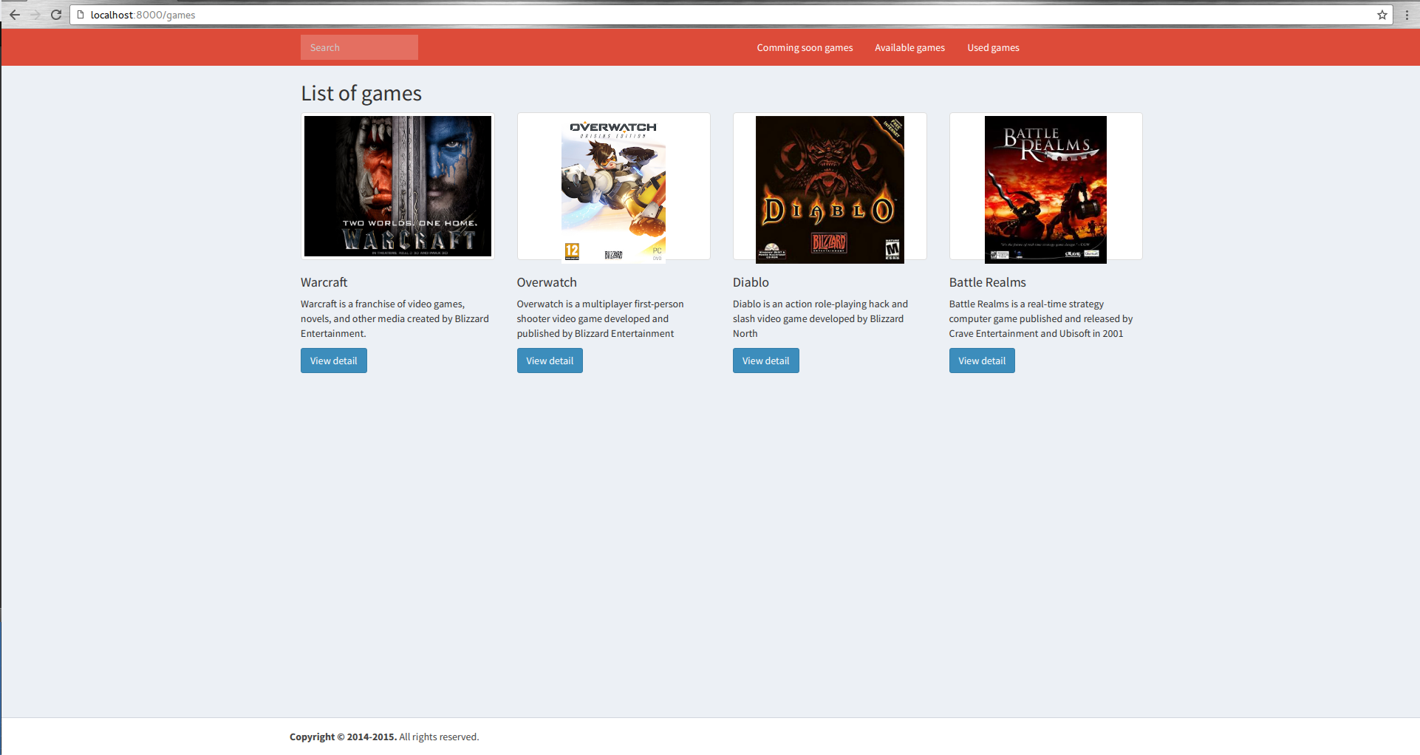

This page shows all stored games. The data is populated by pulling itself from the database. All coming soon data request is sent to database and the query pulls record from the database.

# **Game Detail/Comment Page:**

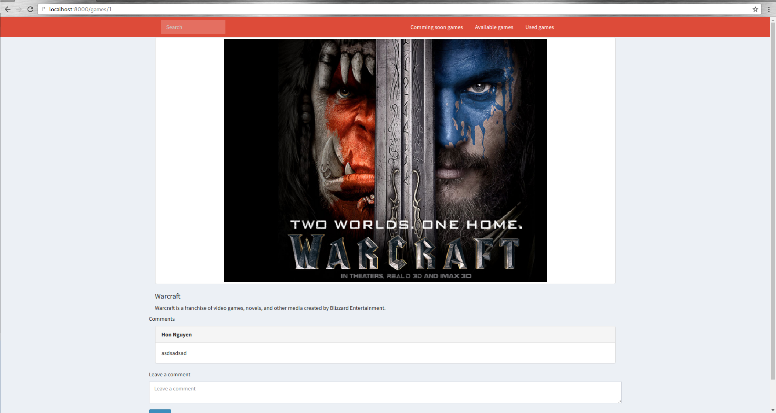

When user clicks on any game, the detail page will appear that shows the detail of that game. On the same page, user can put comments. When user enters comments, the AJAX call through Javascript is sent to database to store comment and that comment is shown on the same page via JQuery.

# **Search Page:**

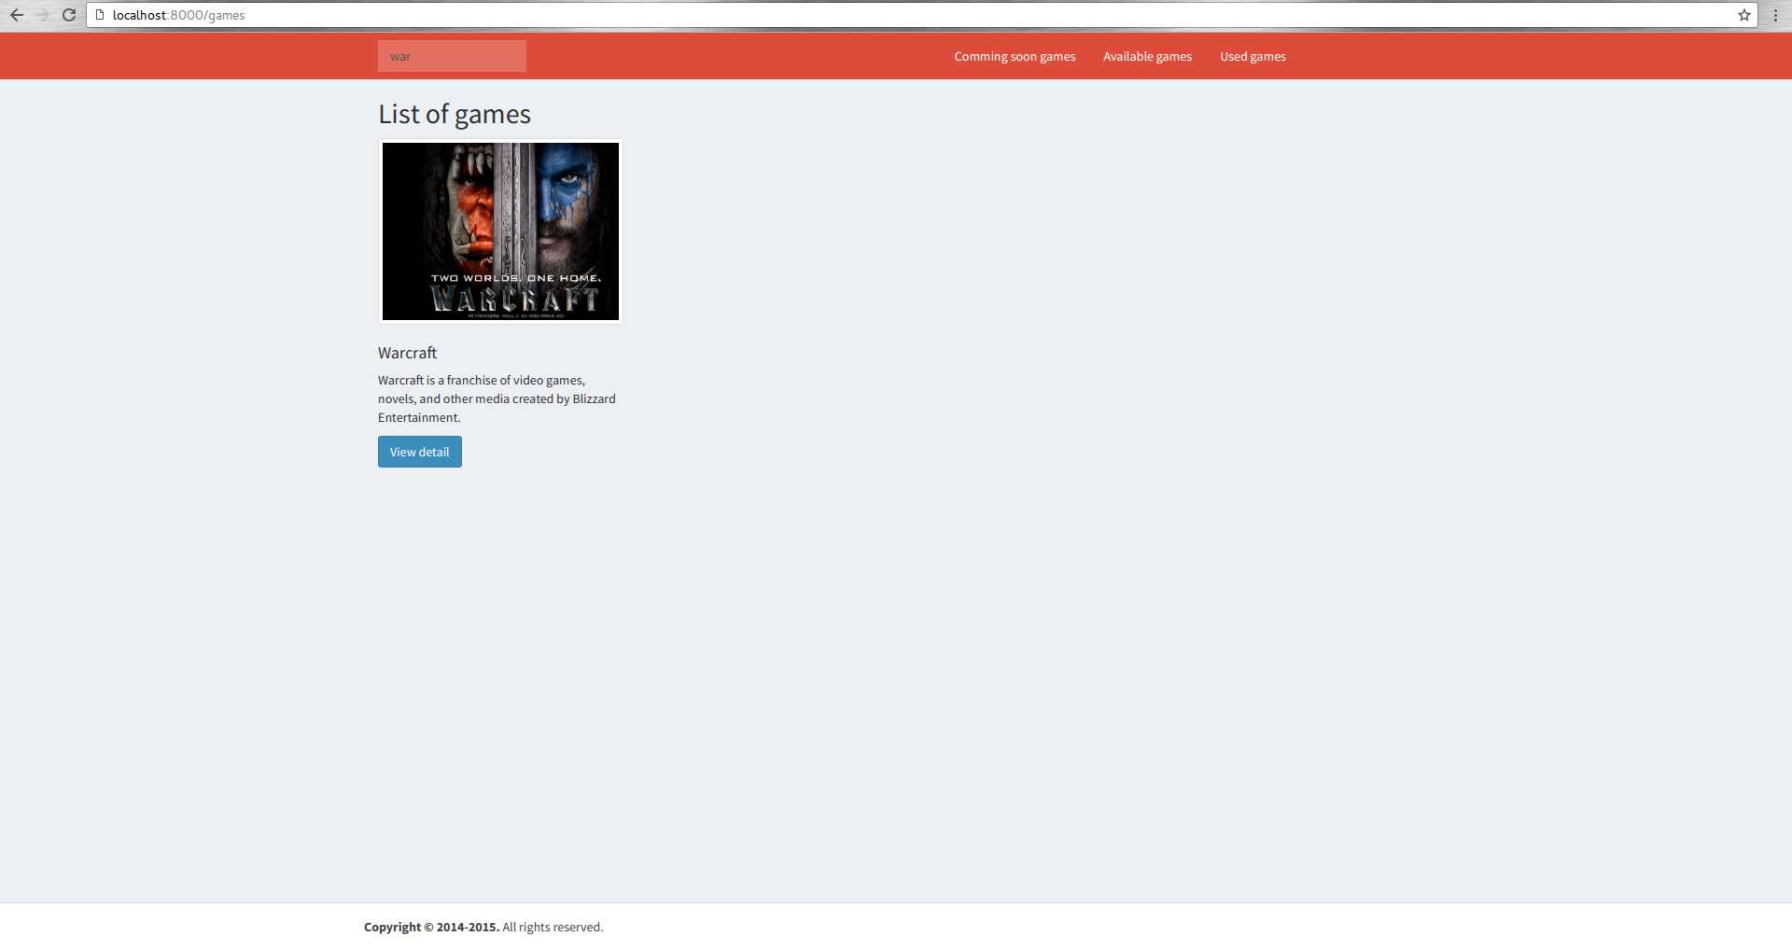

When user search on the search bar and hit enter, the result is shown for that search. When user enters a search string and hit enters, Javascipt gets that strings and send it to database through AJAX call and that is searched from database and the result is returned.